Ex 1 **Setting up a LAMP stack**

**AIM:**

To set up a LAMP stack in Linux and

1. Monitor changes in the stock market using live updates from http://money.rediff.com
2. Using the obtained information from the site through PHP and dynamically update the results
3. Provide storage of values in database in regular intervals.

**INSTALLATION PROCEDURE:**

**Steps to install Apache**

Step 1: First sudo -i

Step 2: Then run

apt-get update

apt-get upgrade

Step 3: Next we shall install Apache, so run the following command:

apt-get install apache2

Step 4: Apache will be downloaded and installed. However, it would not start, reason being as follows:

"apache2: Could not reliably determine the server's fully qualified domain name, using 127.0.1.1 for ServerName"

Step 5: To resolve this issue, we need to create a file called "fqdn" which stands for Fully Qualified Domain Name with the following content. Make sure you start the text editor with root access and save the file into /etc/apache2/conf.d/

"ServerName localhost"

or simply execute the following command:

echo "ServerName localhost" | tee /etc/apache2/conf.d/fqdn

Step 6: By default, Apache points to a website located in /var/www/index.html. We need Apache to point to our own website folder which might be somwhere else,say "home/user/website". In order to do so we need create a new configuration file for this website and make Apache use that file for its usage. Follow the following steps for it:

1) First, make a copy of the default file located under "/etc/apache2/sites-available" and save it as say "site1"

2) Next, Change DocumentRoot "/var/www" to DocumentRoot "/home/dv/website"

3) Then, Change <Directory /var/www/> to <Directory /home/dv/website/>. Save and Exit the file.

Step 7: Now, we need to disable the default setting using the following command

a2dissite default

Then, make active the new site using

a2ensite site1

Step 8: Finally, restart apache.

**Steps to install MySQL server**

Step 1: Use sudo -i command to gain root access. Enter password when prompted.

Step 2: Then run the following command:

apt-get install mysql-client mysql-server mysql-common

**APPLICATION – Algorithm:**

1. Declare the curl function which accepts the URL as the argument
2. Initialize the following CURL options -   
   RETURN TRANSFER, FOLLOW LOCATION, AUTO REFERRER, CONNECT TIMEOUT, TIMEOUT, MAXREDIRS, USERAGENT, URL accordingly in an array.
3. Initialize the curl handler using curl_init()
4. Set all the url options declared in the array with the handler using the function curl_set_opt_array($ch,$options)
5. Set the proxy using curl_set_op($ch,curlopt_proxy,’proxy.ssn.net:8080’)
6. Execute the curl using curl_exec()
7. The webpage data returned is stored in a variable
8. Declare a function scrape_between() accepting the webpage data with data, start, end as arguments
9. Using the curl() function, read the contents of the web page “money.rediff.com”
10. Using the scrape_between function, find the BSE and NSE stock values along with the daily changes and print them.
11. Connect to the mysql database using mysqli_connect() using “root” as user and “ssn” as password
12. Using mysqli_query() write a query to insert details into besupdates table.
13. Close the connection using mysqli_close()

**PROGRAM CODING:**

File Name: index.html

<html>

<head>

<title>

Market Analysis | Client

</title>

<link href="css/main_page.css" type="text/css" rel="stylesheet" />

</head>

<body>

<div id="content" align="center">

<a href="stock.php">

Click here for latest stock updates

</a>

</div>

</body>

</html>

File Name: main_page.css

body {

margin: 0;

}

#content {

position: relative;

top: 100px;

width: 40%;

height: 400px;

margin-left:auto;

margin-right:auto;

border: 2px solid #123456;

}

a{

position: relative;

margin-left:auto;

margin-right:auto;

top:45%;

background-color: #123456;

padding: 10px;

text-decoration: none;

color: #FFF;

}

* {

padding: 10px;

}

table{

position: relative;

margin:auto;

top: 30%;

border: 2px solid #123456;

}

th{

background-color:#123456;

color:#FFF;

}

File: stock.php

<!--PHP Curl Part -->

<?php

// Defining the basic scraping function

functionscrape_between($data, $start, $end){

$data = stristr($data, $start); // Stripping all data from before $start

$data = substr($data, strlen($start)); // Stripping $start

$stop = stripos($data, $end); // Getting the position of the $end of the data to scrape

$data = substr($data, 0, $stop); // Stripping all data from after and including the $end of the data to scrape

return $data; // Returning the scraped data from the function

}

// Defining the basic cURL function

function curl($url) {

// AssigningcURL options to an array

$options = Array(

CURLOPT_RETURNTRANSFER => TRUE, // Setting cURL's option to return the webpage data

CURLOPT_FOLLOWLOCATION => TRUE, // Setting cURL to follow 'location' HTTP headers

CURLOPT_FRESH_CONNECT => TRUE, //Setting a fresh connection for every read

CURLOPT_AUTOREFERER => TRUE, // Automatically set the referer where following 'location' HTTP headers

CURLOPT_CONNECTTIMEOUT => 120, // Setting the amount of time (in seconds) before the request times out

CURLOPT_TIMEOUT => 120, // Setting the maximum amount of time for cURL to execute queries

CURLOPT_MAXREDIRS => 10, // Setting the maximum number of redirections to follow

CURLOPT_USERAGENT => "Mozilla/5.0 (X11; U; Linux i686; en-US; rv:1.9.1a2pre) Gecko/2008073000 Shredder/3.0a2pre ThunderBrowse/3.2.1.8", // Setting the useragent

CURLOPT_URL => $url, // Setting cURL's URL option with the $url variable passed into the function

);

$ch = curl_init(); // InitialisingcURL

curl_setopt_array($ch, $options); // Setting cURL's options using the previously assigned array data in $options

curl_setopt($ch, CURLOPT_PROXY, 'proxy.ssn.net:8080');

$data = curl_exec($ch); // Executing the cURL request and assigning the returned data to the $data variable

curl_close($ch); // Closing cURL

return $data; // Returning the data from the function

}

?>

<!--PHP- BSE/NSE Part-->

<?php

$url = "http://money.rediff.com"; // Assigning the URL we want to scrape to the variable $url

$results_page = curl($url); // Downloading the results page using our curl() funtion

$bse_page = scrape_between($results_page, "<div id=\"sensTab1\"","<div id=");

$nse_page = scrape_between($results_page, "<div id=\"sensTab2\"","<div id=");

$bse_index_value = scrape_between($bse_page, "<span id=\"bseindex\" class=\"black\">", "</span>"); // Scraping out only the middle section of the results page that contains our results

$bse_day_change = scrape_between($bse_page, "<span class=\"red\"", "/div>");

$bse_day_change_value = scrape_between($bse_day_change, ">", "</span>");

$bse_day_change_percent = scrape_between($bse_day_change, "</span>", "<");

$nse_index_value = scrape_between($nse_page, "<span id=\"nseindex\" class=\"black\">", "</span>"); // Scraping out only the middle section of the results page that contains our results

$nse_day_change = scrape_between($nse_page, "<span class=\"red\"", "/div>");

$nse_day_change_value = scrape_between($nse_day_change, ">", "</span>");

$nse_day_change_percent = scrape_between($nse_day_change, "</span>", "<");

?>

<!--PHP-DB Connection Part-->

<?php

$con=mysqli_connect("","root","ssn","stockmarket");

// Check connection

if (mysqli_connect_errno($con))

{

echo "Failed to connect to MySQL: " . mysqli_connect_error();

}

//else

//echo "Connection established";

mysqli_query($con,"INSERT INTO bseupdates (stockvalue, dayvalue, percent)

VALUES ('$bse_index_value', '$bse_day_change_value','$bse_day_change_percent')");

mysqli_close($con);

?>

<html>

<head>

<script>

var c = window.setInterval(function(){document.location.reload(true);},3000);

</script>

<link href="css/main_page.css" type="text/css" rel="stylesheet" />

</head>

<body>

<div id="content">

<table rules="all">

<tr>

<th>Market</th><th>Current Value</th><th>Daily Change</th><th>% Change</th>

</tr>

<tr>

<td>BSE</td>

<td>

<?php

echo $bse_index_value;

?>

</td>

<td>

<?php

echo $bse_day_change_value;

?>

</td>

<td>

<?php

echo $bse_day_change_percent;

?>

</td>

</tr>

<tr>

<td>NSE</td>

<td>

<?php

echo $nse_index_value;

?>

</td>

<td>

<?php

echo $nse_day_change_value;

?>

</td>

<td>

<?php

echo $nse_day_change_percent;

?>

</td>

</tr>

</table>

</div>

</body>

</html>

**Screenshots:**

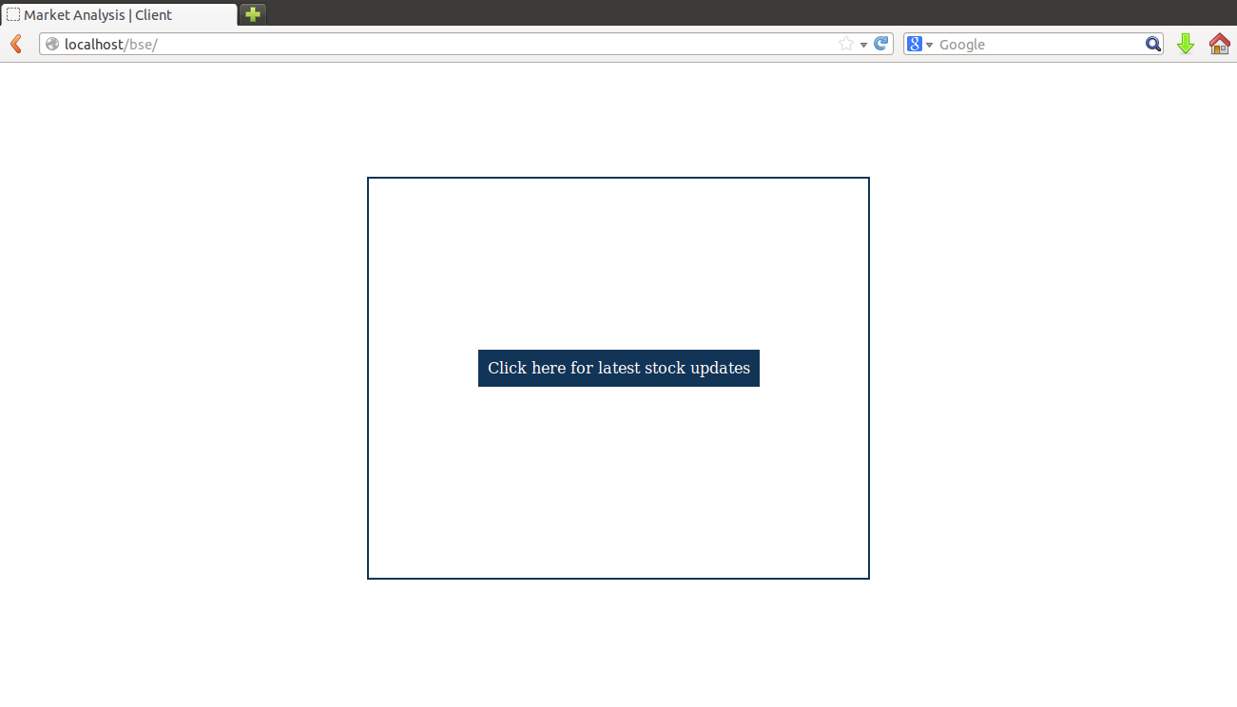

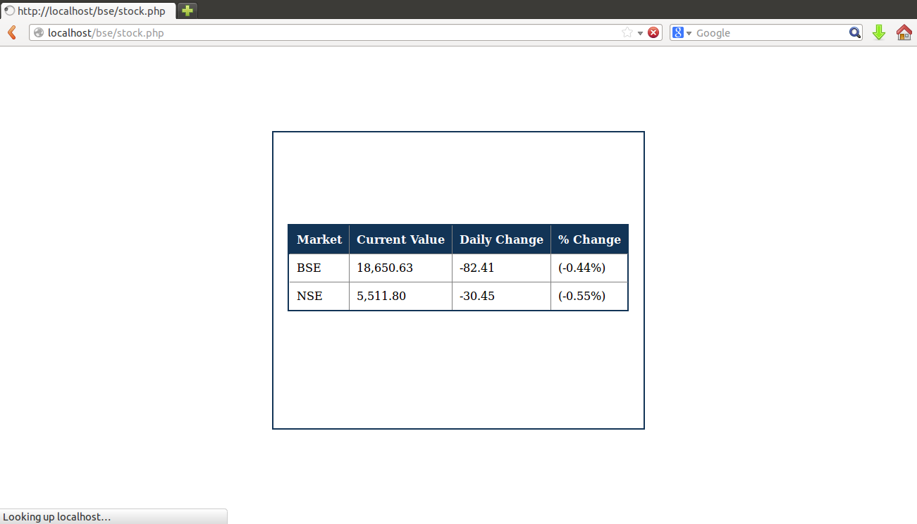

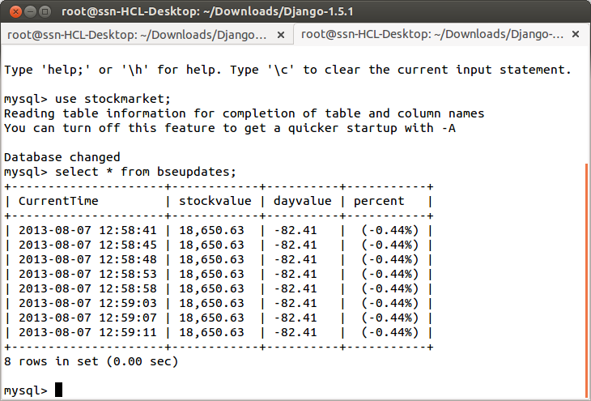

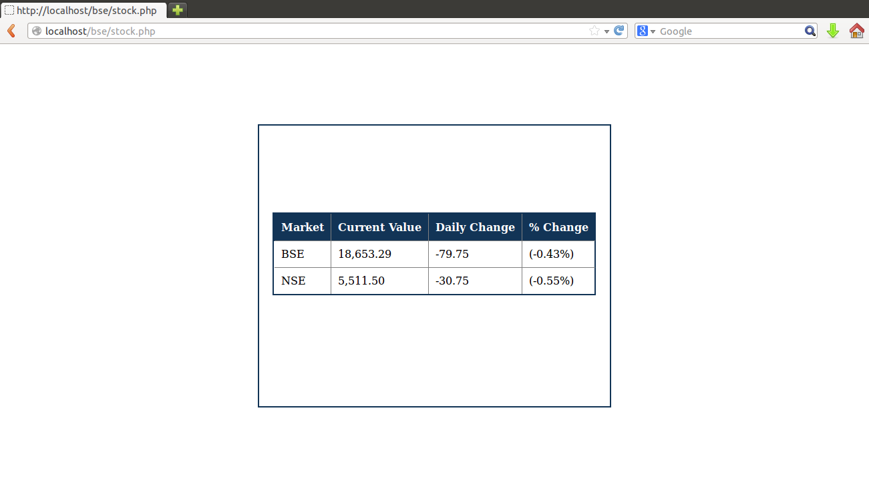

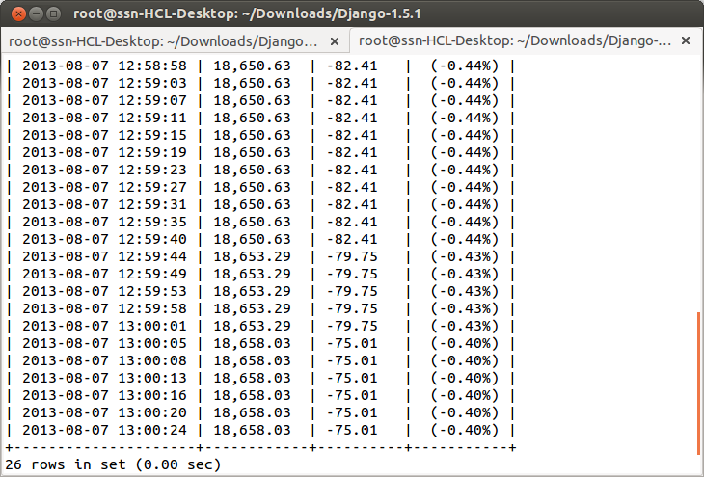

**RESULT**

Apache server was installed in Ubuntu Desktop Environment. MySQL server was also installed. A client HTML page was written to connect to a PHP page on the server that retrieves data from http://money.rediff.com and provide regular updates on BSE and NSE stock values. Text processing was done using the cURL package. The data was in parallel, updated into a relational schema in MySQL database.